**DAILY ASSESSMENT FORMAT**

|  |  |  |  |
| --- | --- | --- | --- |
| **Date:** | **30/05/2020** | **Name:** | **SHALIVAHAN** |
| **Course:** | **Python** | **USN:** | **4AL18EC047** |
| **Topic:** | Python for image and video processing with openCV | **Semester & Section:** | **4th Sem**  **‘A’ Section** |
| **Github Repository:** | **shalivahan1** |  |  |

**FORENOON SESSION**

**Image of the session**

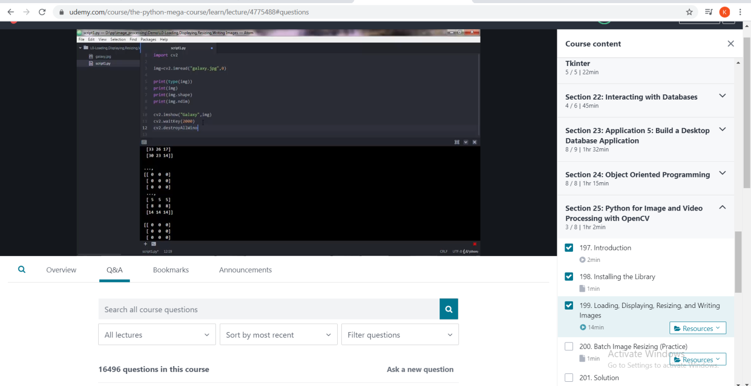

BUILDING A WEBCAM MOTION DETECTION:

*ode picks up on motion very well, you can fiddle with the threshold variable (sdThresh) to make it near perfect for your camera and the lighting conditions etc.

*A good start setting for sdThresh is usually around 15 to 20.

*The tutorial carried on to add face recognition as well. That’s not quite in my remit yet, though I hope to get around to learning face recognition at some stage.

*I need to learn the basics of Opencv first, so here we are.

*All the credit must go to the original author(s), thank you, and I hope you don’t mind me cannibalizing your lovely code.

*I’m just an amateur mucking about and trying to learn.